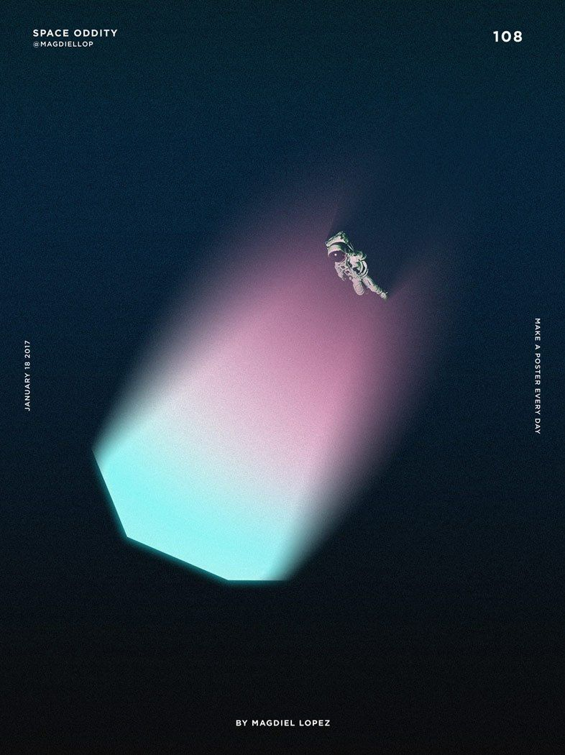

**Project Proposal and MongoDB Design for Social Media Website / FocusON-X.**

**2023-24 CST2120 Web Applications and Databases**

**Coursework 2: Project Proposal & MongoDB Design**

**Module Teacher:**

**Dr David Gamez - Module leader (Hendon)**

**Adam Philpot (Hendon)**

**Created by Arbaaz Ali Hussain - M00872279**

**Submission date: 26/01/24, 16:00 to 18:00 pm**

**Middlesex London University Computer Science School**

**Word Count: 1387**

Table of Contents

Introduction 5

The Reason for Creating My Specific Social Media “FocusON-X” 5

The Social Media Website Design / FocusON-X 6

Screenshots 1 the “FocusON-X”. 6

Screenshots 2. 7

Screenshots 3. 8

Screenshots 4. 9

Screenshots 5. 10

Screenshots 6. 11

Screenshots 7. 12

Screenshots 8. 13

Screenshots 9. 14

Screenshots 10. 15

Screenshots 11. 16

Screenshots 12. 17

Screenshots 13. 18

Screenshots 14. 19

The MongoDB 21

Screenshots 1 of the MongoDB 21

Screenshots 2 of the MongoDB 23

# Introduction

Within this documentation for the project proposal, I have been ordered to create a social media website that will be displayed on the web browser. The social media website concepts and functionalities are up to me observe and create a social media website which meets all the requirements for the social media design/layout, also providing a phenomenal excellent user experience when interacting with the social media website.

# The Reason for Creating My Specific Social Media “FocusON-X”

The reason for creating my specific social media is based on two social media platforms one being Instagram and the other being YouTube. The reason I have chosen to combine these social media platforms to create a new type of social media platform which will be interesting, fun, and creating something which will be new but reminiscing to the old social media platforms, as both social media platforms, which I have been using when I was young child and currently using these platforms to this day. Furthermore, when this social media platform has been completed and ready to be utilised, hopefully people will find this social media platform to be fun, easy, and rememberable.

# The Social Media Website Design / FocusON-X

## Screenshots 1 the “FocusON-X”.

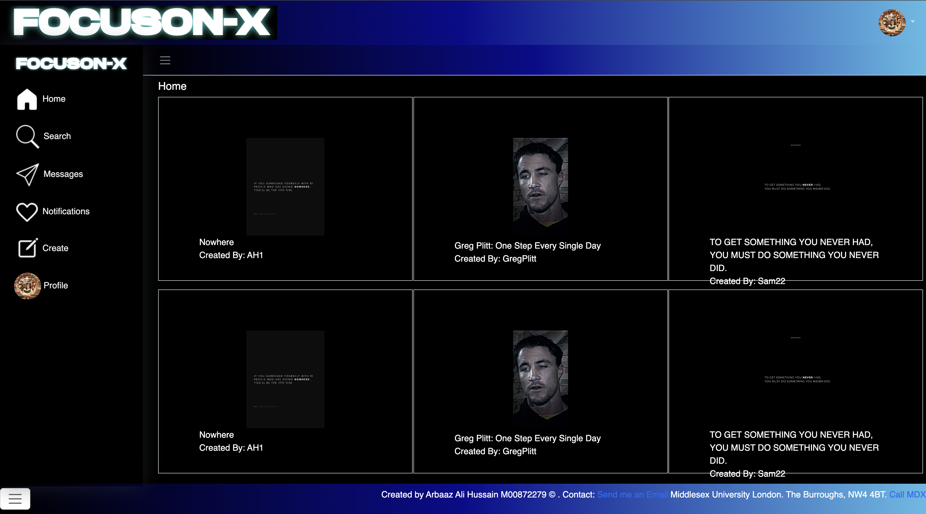

Here is my screenshot 1 of the FocusON-X website, in the wireframe is the main page that the users will be introduced to allowing the users to interact with the website without an account, but this of course has limitations to it. This website is intensely interactive, easy to use, and formative does lead to a stimulus experience.

Additionally, this provides the user for more information regarding the website through its footer which contains a GitHub account and an email.

## Screenshots 2.

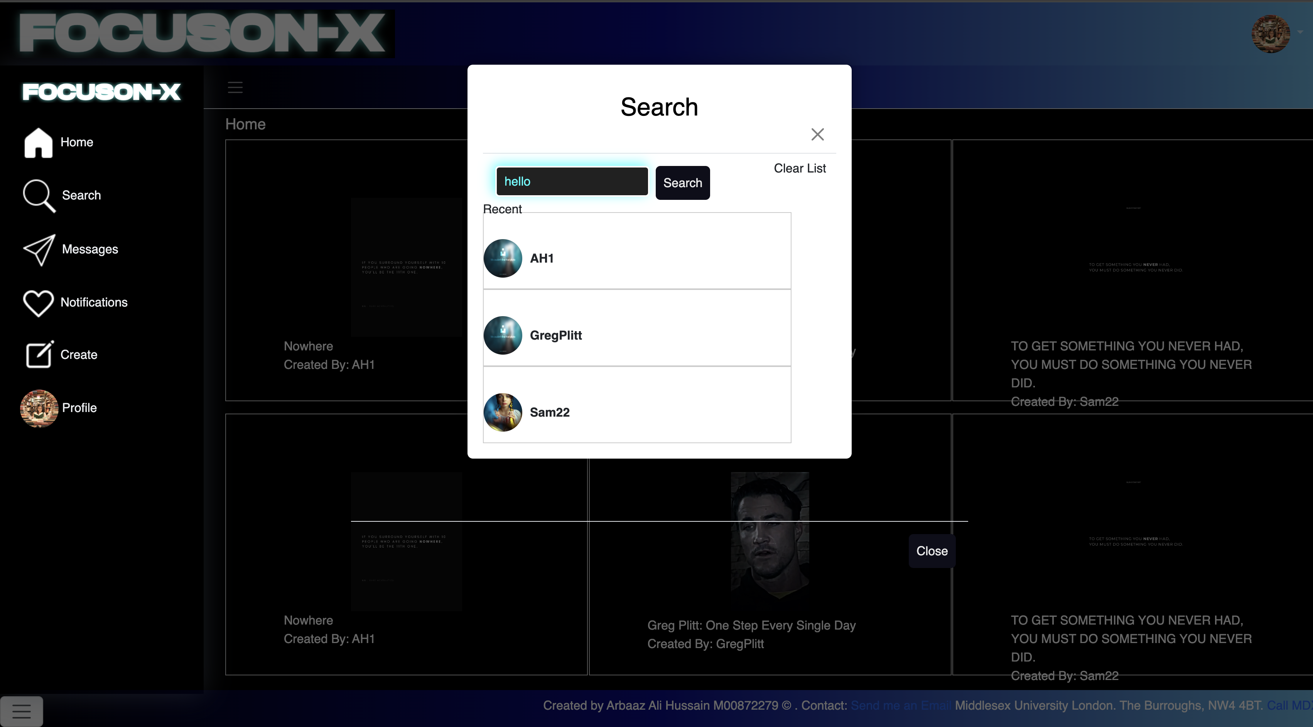

## Here is my screenshot 2 of the FocusON-X website, in the wireframe, there is an interactive panel which is activated when the user selected the search icon. This allows for the user to search up any user to view the profile, follow them or to message them etc. And find uses flawlessly without any error. Furthermore, the user can select the video or image by selecting the video icon on the main page this unable to use it to view the contents.

## Screenshots 3.

## Here is my screenshot 3 of the FocusON-X website, in the wireframe, there is an interactive panel which is activated when the user selected the message icon. This allows for the user to message each other in real time and sharing videos and images in the form of direct messaging to a user and allowing user to message new users by selecting new message icon.

## Screenshots 4.

## 

## Here is my screenshot 4 of the FocusON-X website, in the wireframe, there is an interactive panel which is activated when the user selected the notification icon. This for the user to be informed regarding their post and current users that are following them.

## Screenshots 5.

## Here is my screenshot 5 of the FocusON-X website, in the wireframe, there is an interactive panel which is activated when the user selected the create icon. This is where the user can create a new post on the social media website, which allows us to upload an image or video, or even a URL link to be created as a post. Additionally, allowing to use it to have a description/title for the post.

## Screenshots 6.

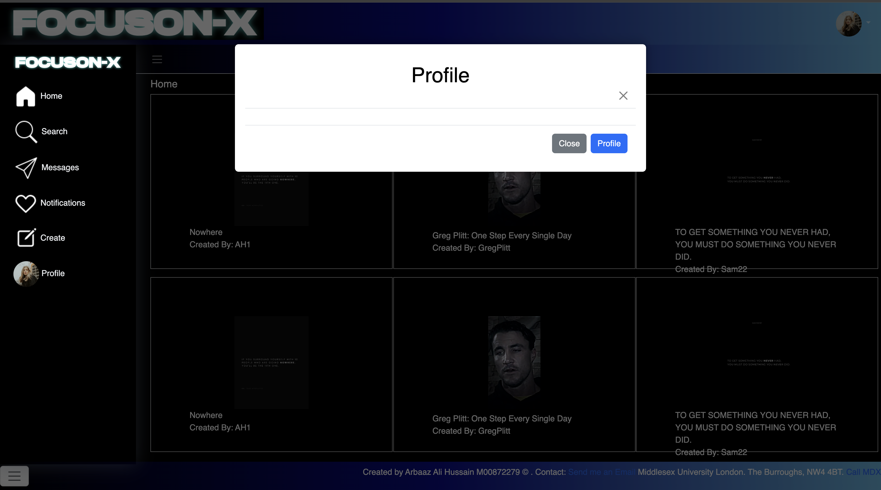

## Here is my screenshot 6 of the FocusON-X website, in the wireframe, there is an interactive panel which is activated when the user selected the profile icon. This is where the user can select their own profile through selecting the profile icon or on the top right the users image. In here can user see all their post, followers, and follow alongside with their description/bio.

## Screenshots 7.

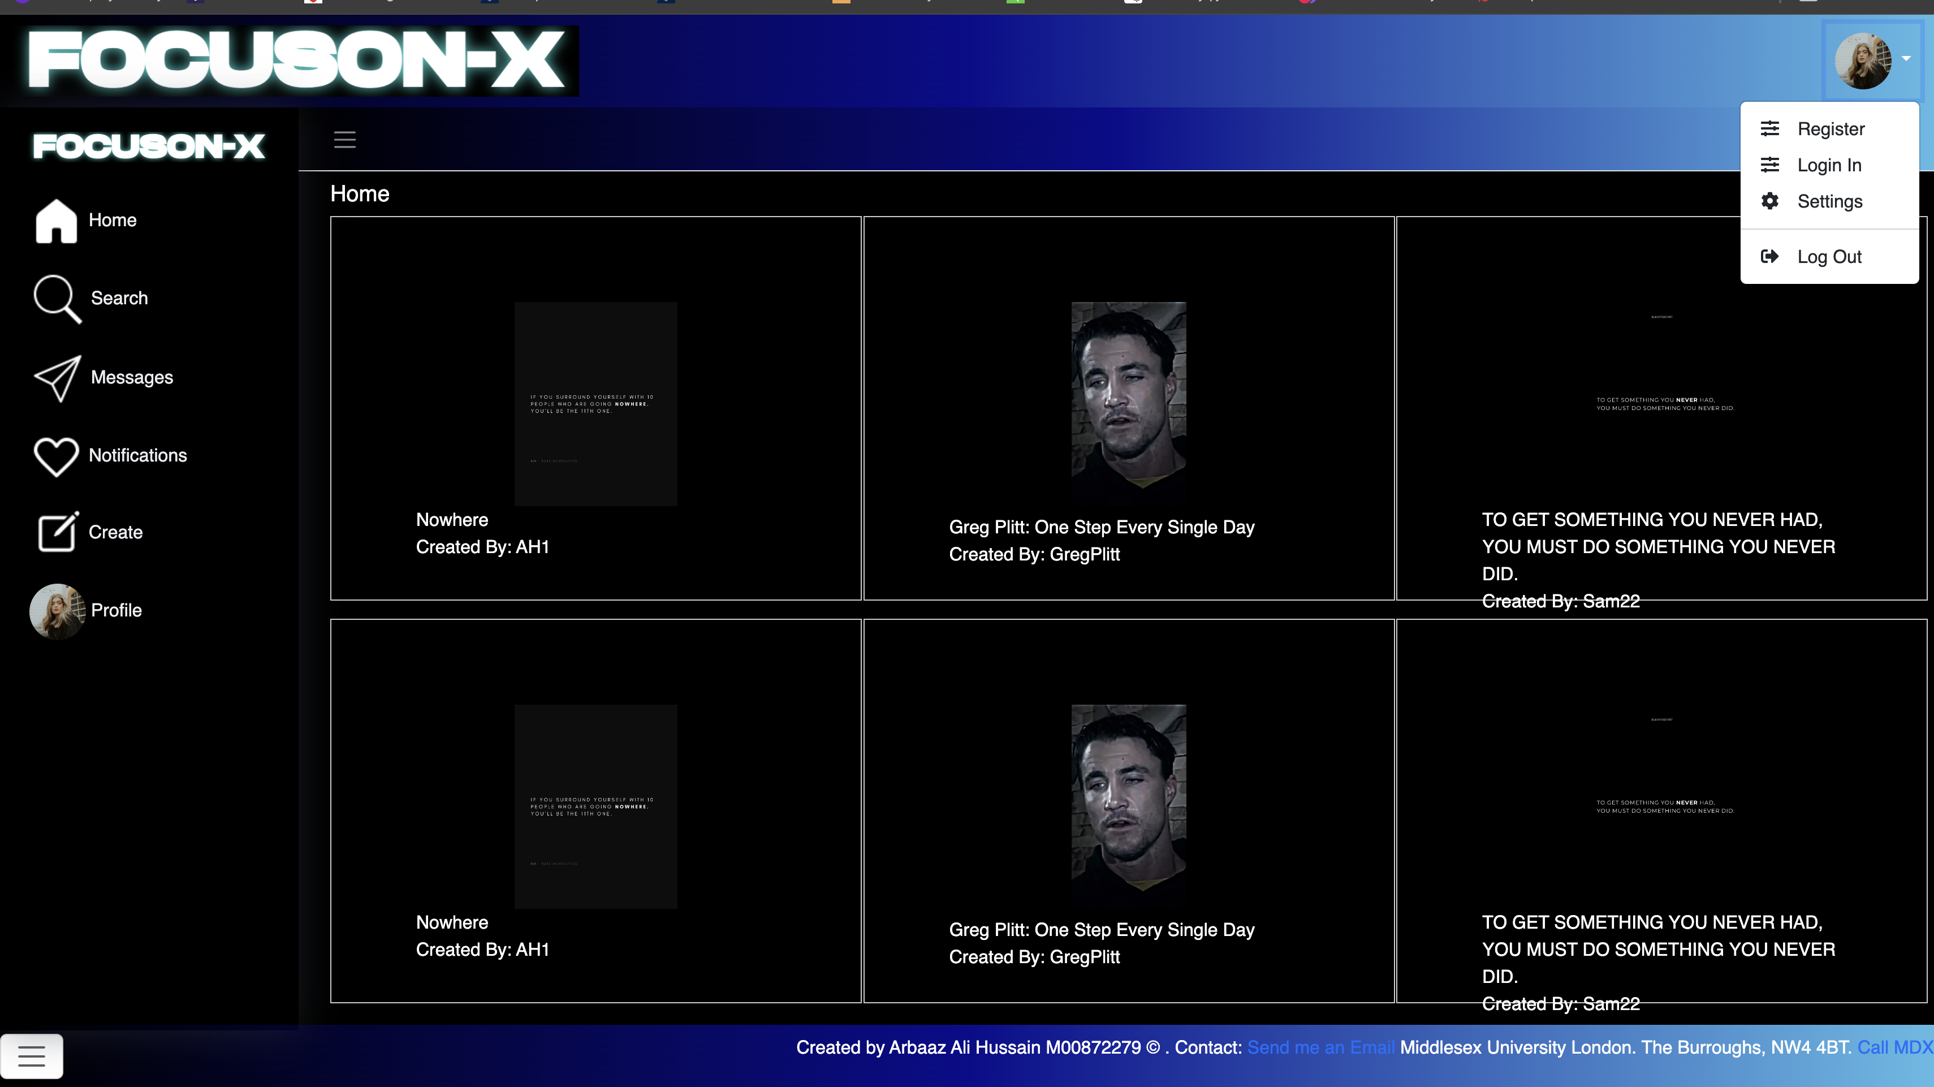

Here is my screenshot 7 of the FocusON-X website, in the wireframe, there is an interactive panel which is activated when the user selected the profile icon or account image. As this is the initial step for create an account or login in, this will direct user to chosen path.

## Screenshots 8.

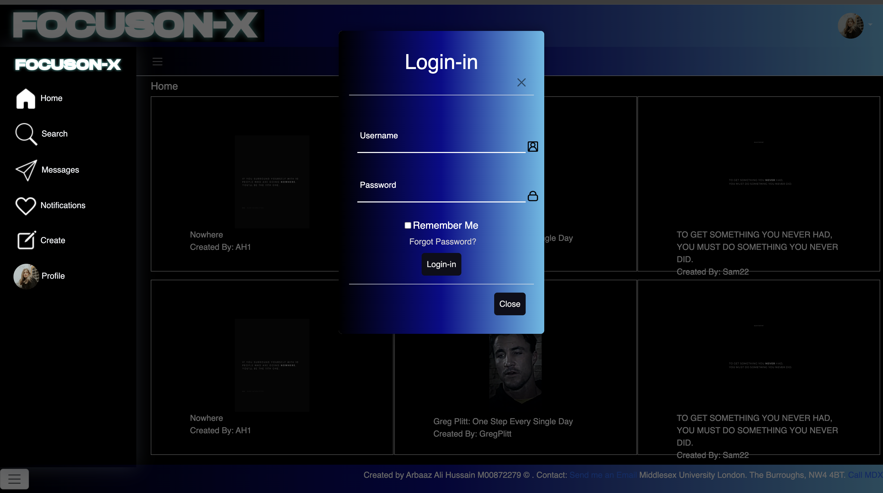

Here is my screenshot 8 of the FocusON-X website, in the wireframe, there is an interactive panel which is activated when the user selected the profile icon or account image. Here the user will be prompt login the account, you can either enter the email, phone number or username and then enter their password. Addition user could save the password for login time. User has forgotten the password they can have the ability to change the password.

## Screenshots 9.

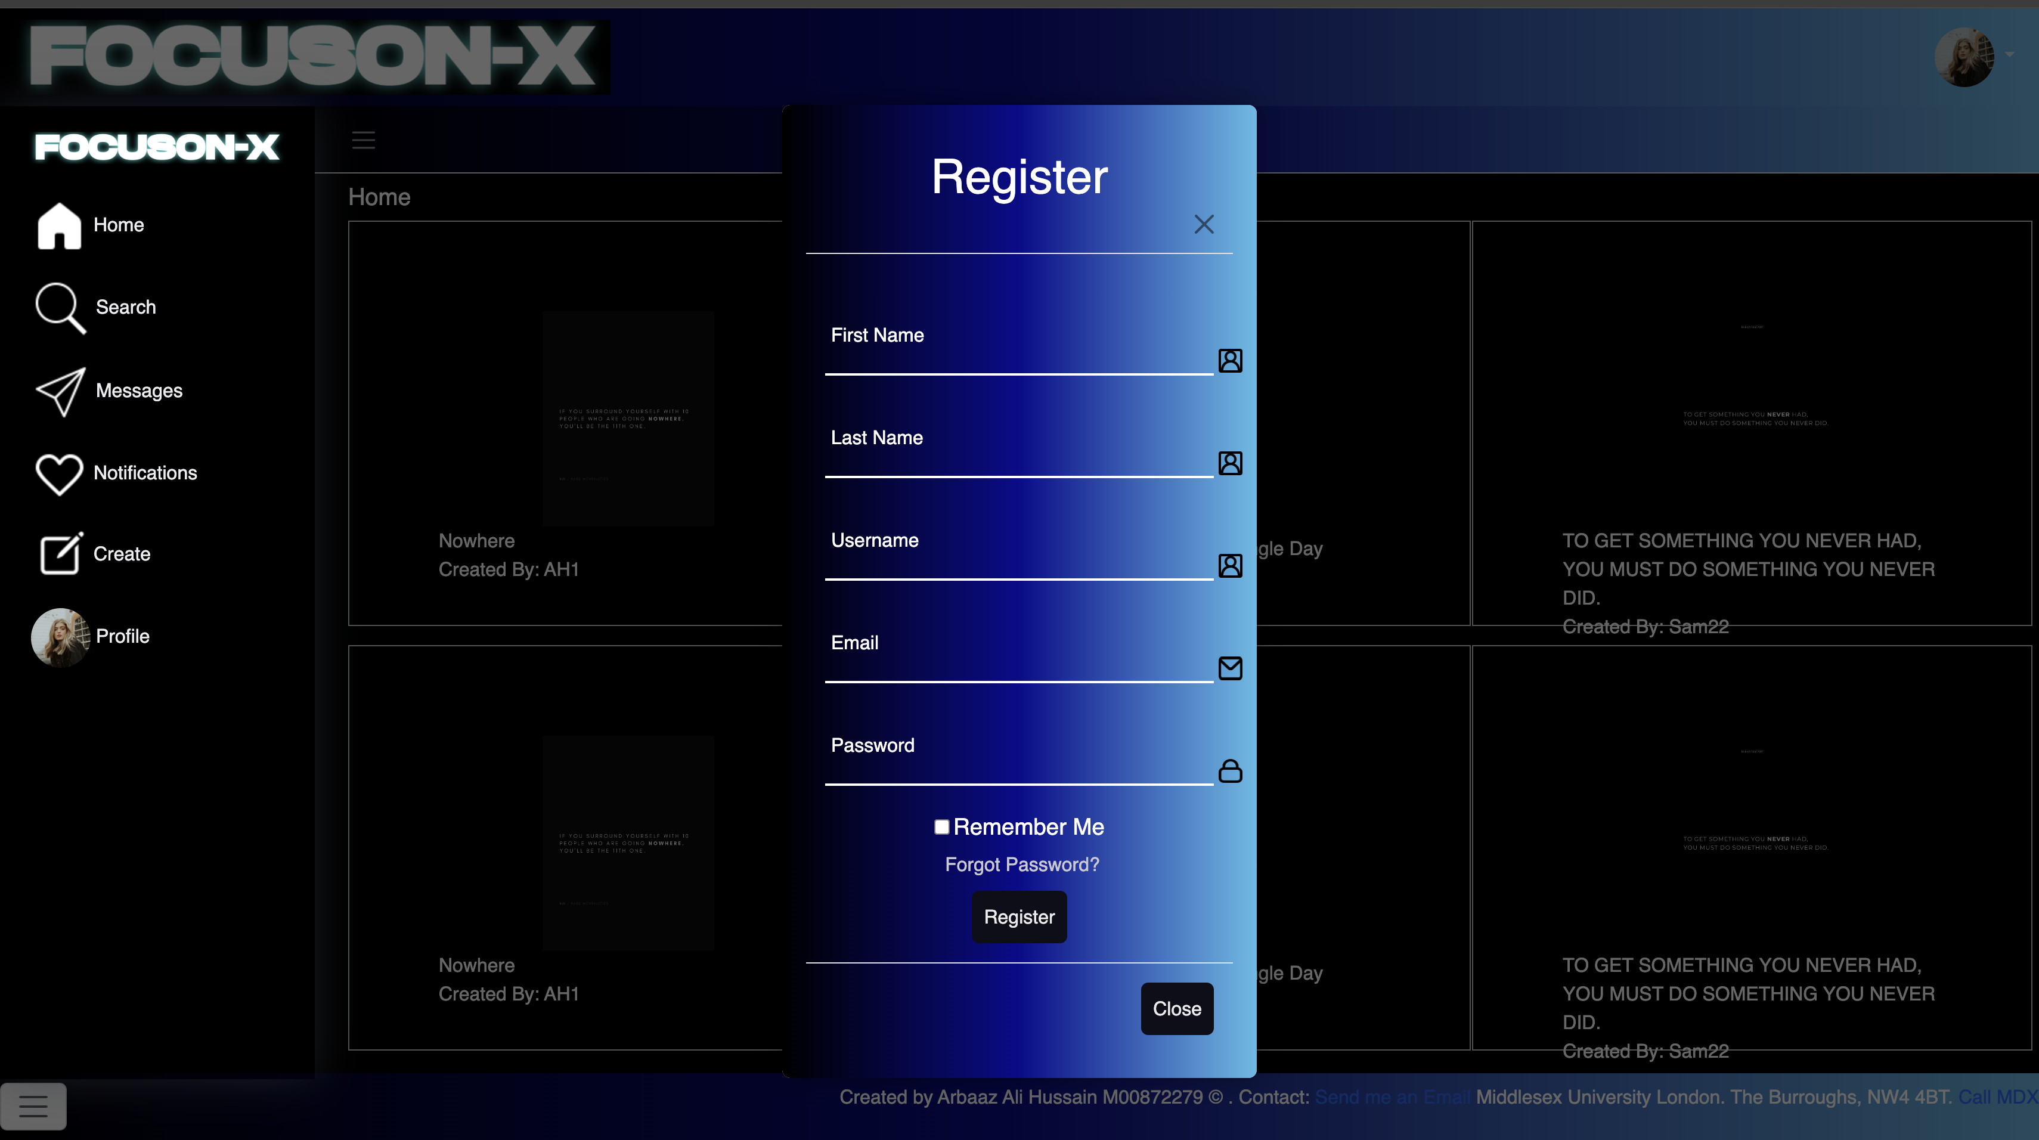

Here is my screenshot 9 of the FocusON-X website, in the wireframe, there is an interactive panel which is activated when the user selected the profile icon or account image. Here the user can create an account by the following first name, last name, phone number, username, email, and password, once completed user has created their account and ability use it.

## Screenshots 10.

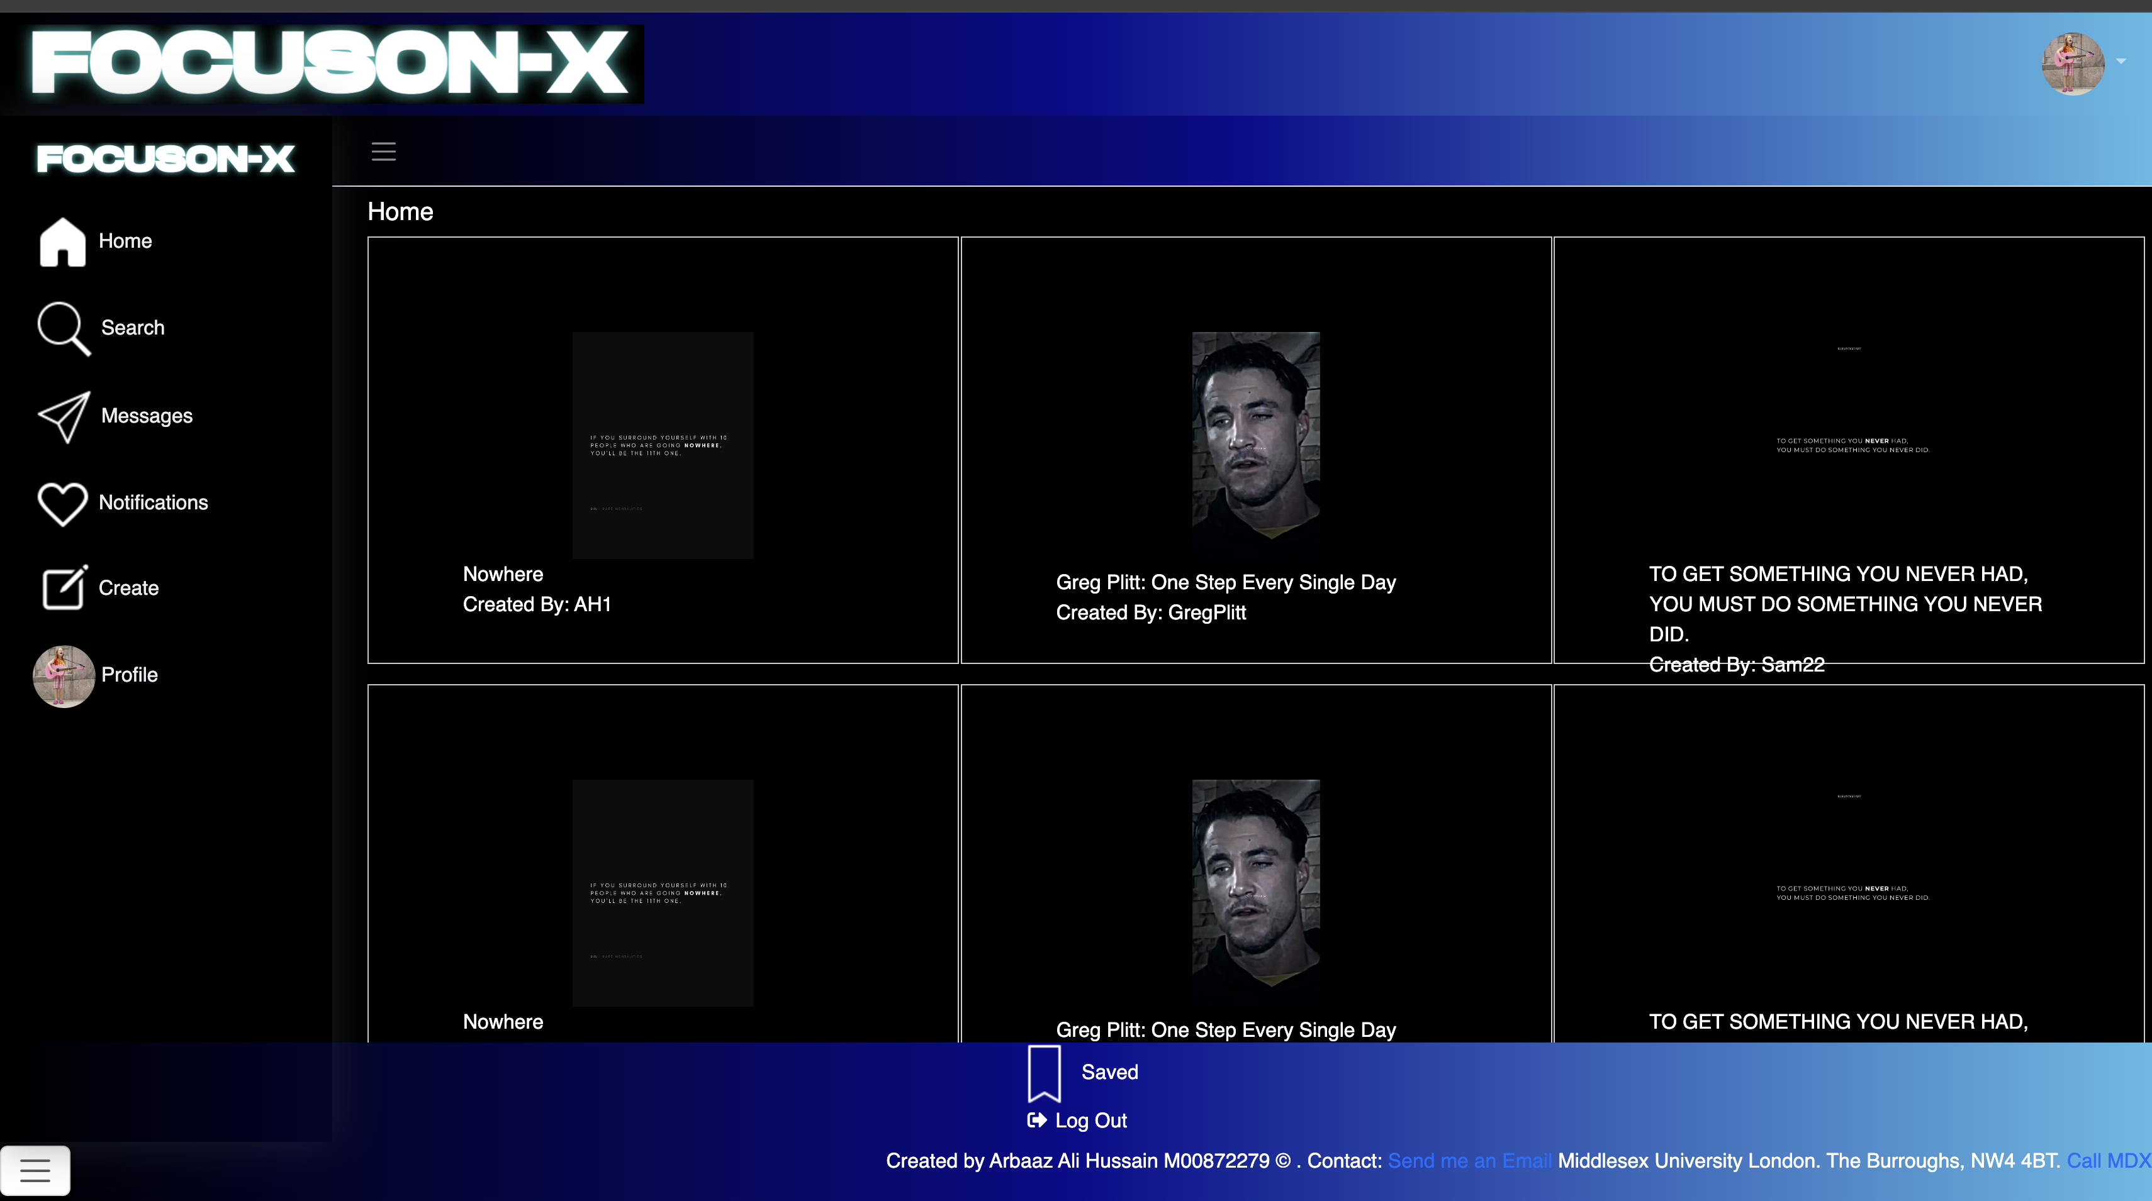

Here is my screenshot 10 of the FocusON-X website, in the wireframe, there is an interactive panel which is activated when the user selected the more icon. Here is where user has the accessibility to save any contact or going to settings and change characteristics or simply logout their account.

## Screenshots 11.

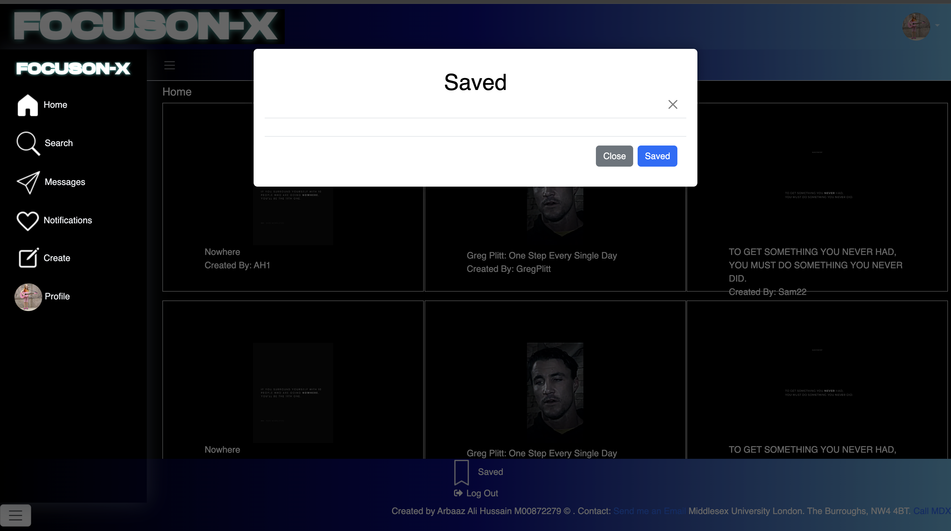

## Here is my screenshot 11 of the FocusON-X website, in the wireframe, there is an interactive panel which is activated when the user selected the more icon. Here is the save contents section which, which displays all the following content videos/images that have been saved by the user, the user can view the content at any time or remove saved videos if wanted.

## Screenshots 12.

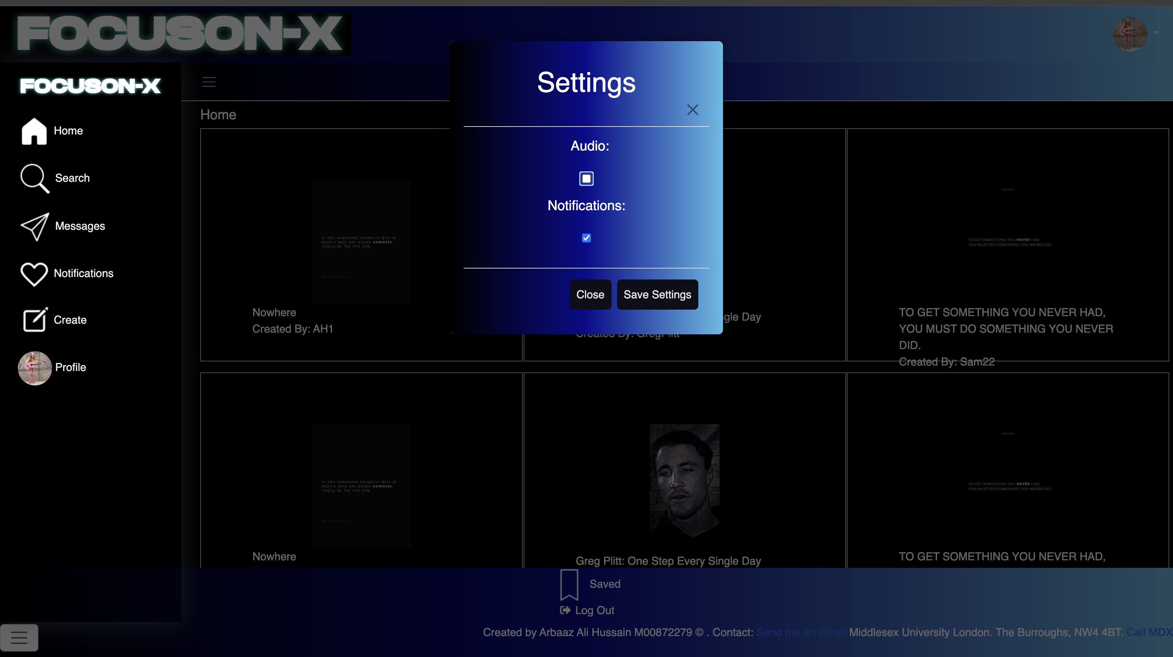

## Here is my screenshot 12 of the FocusON-X website, in the wireframe, there is an interactive panel which is activated when the user selected the more icon. Here is the setting section which allows the user to alter the experience of their website to able or disable all the notifications or to remove audio or allow audio to play.

## Screenshots 13.

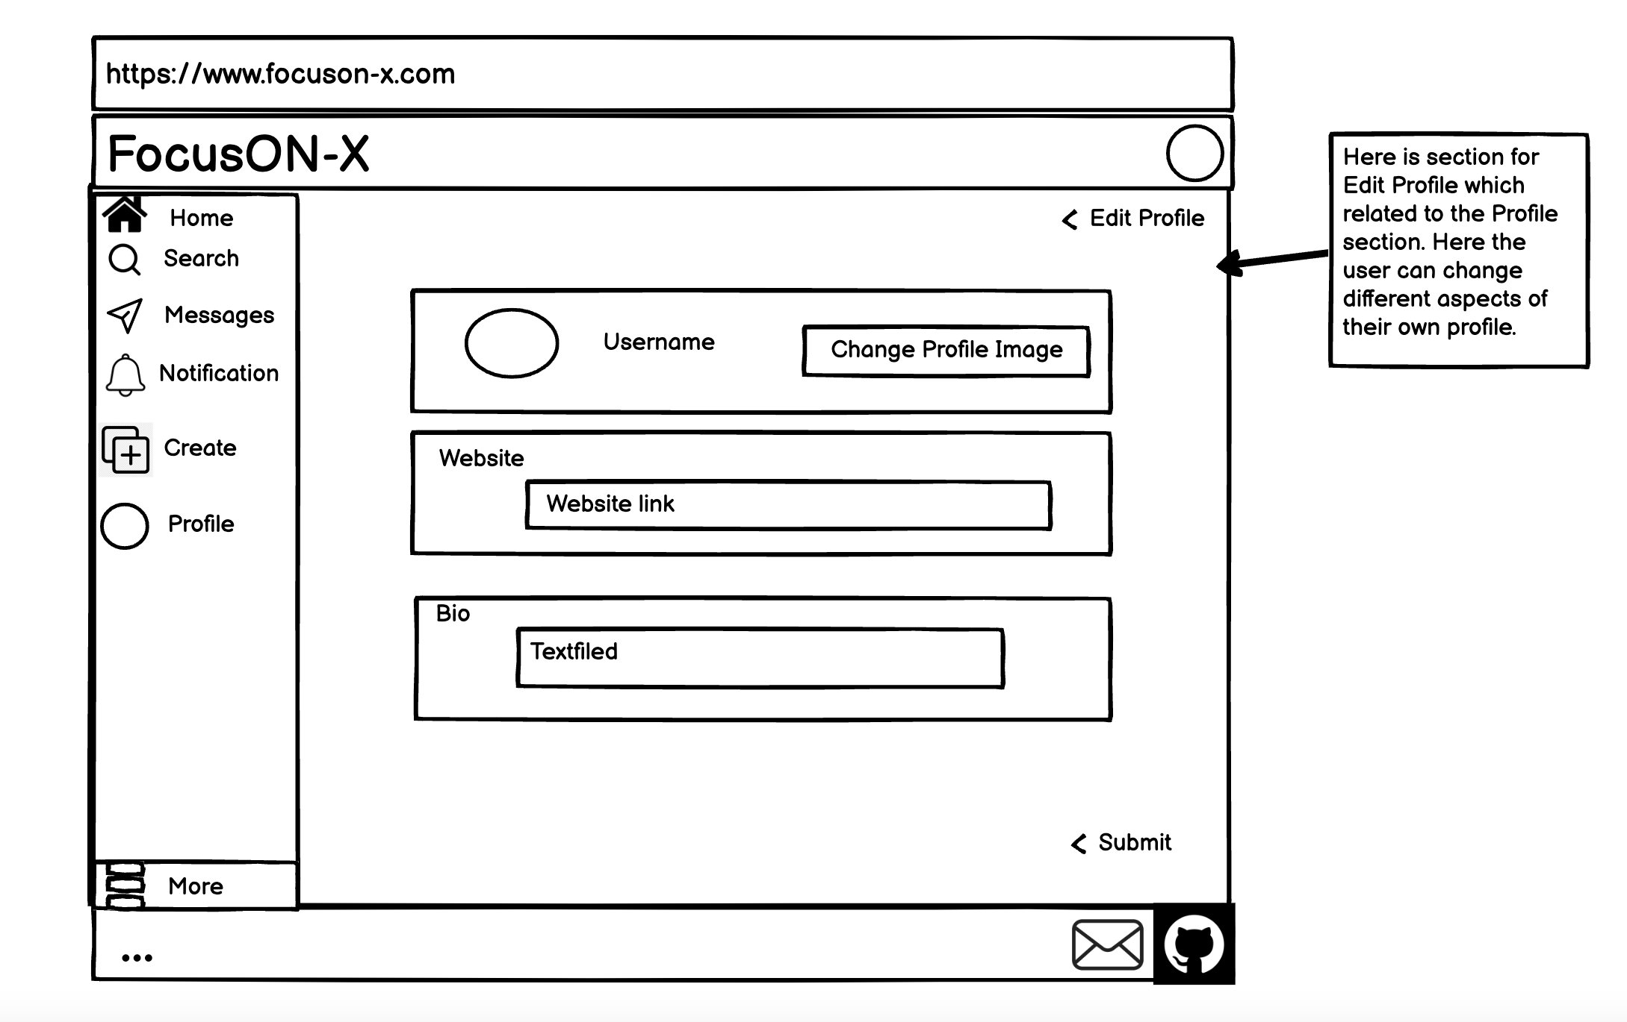

## Here is my screenshot 13 of the FocusON-X website, in the wireframe, there is an interactive panel which is activated when the user selected the profile icon then selecting edit profile. This allows us to change their profile image, website link to the profile or to create a sentence for the bio.

## Screenshots 14.

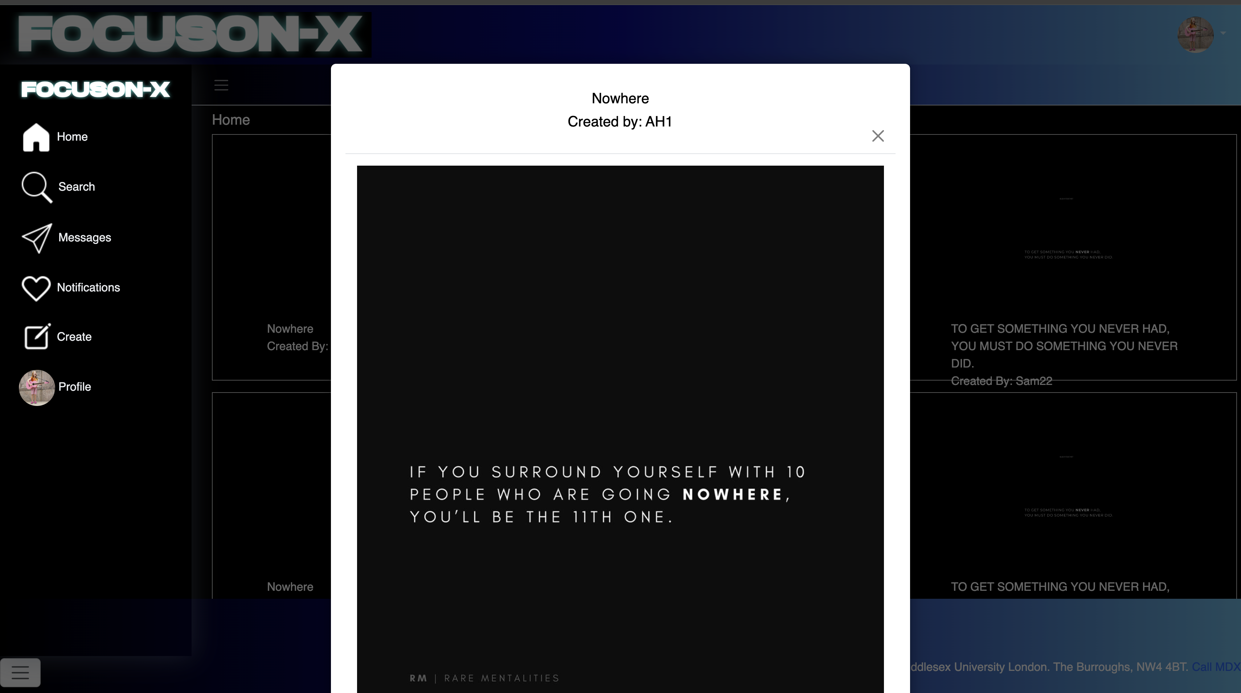

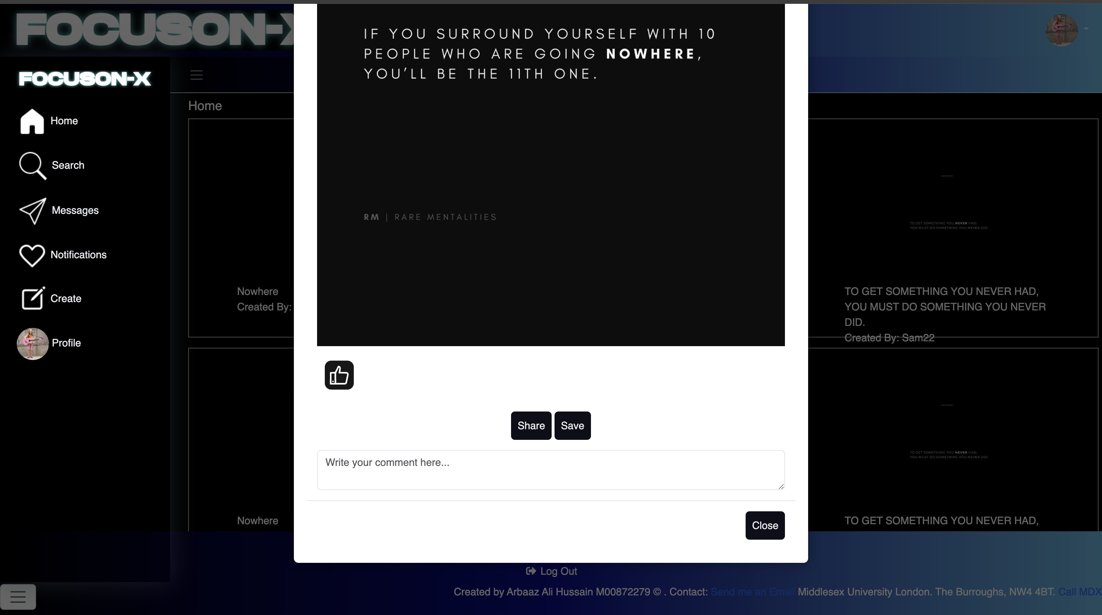

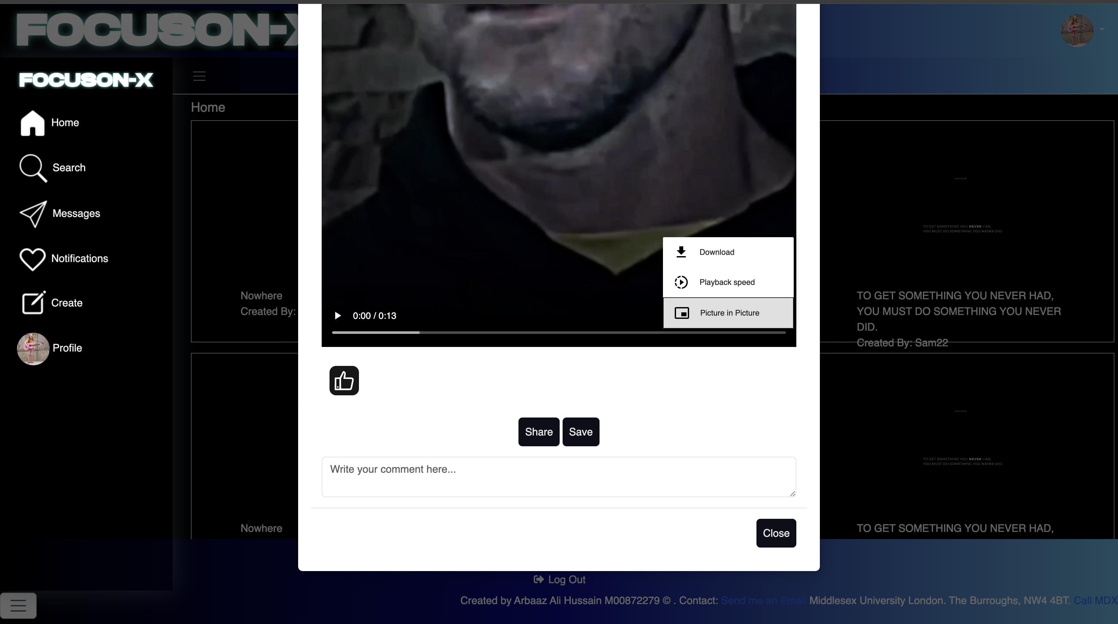

# Here is my screenshot 14 of the FocusON-X website, in the wireframe, there is an interactive panel which is activated when the user selected the video/image. Here is when the users select the video/image, a window appear displaying the video or image, alongside a comment section, ability to like, save and share video to different users.

# The MongoDB

## Screenshots 1 of the MongoDB

Here is a Collection of two data types in MongoDB for the initial database, which contains the following collections: Posts & Users. Here are the screenshots down below:

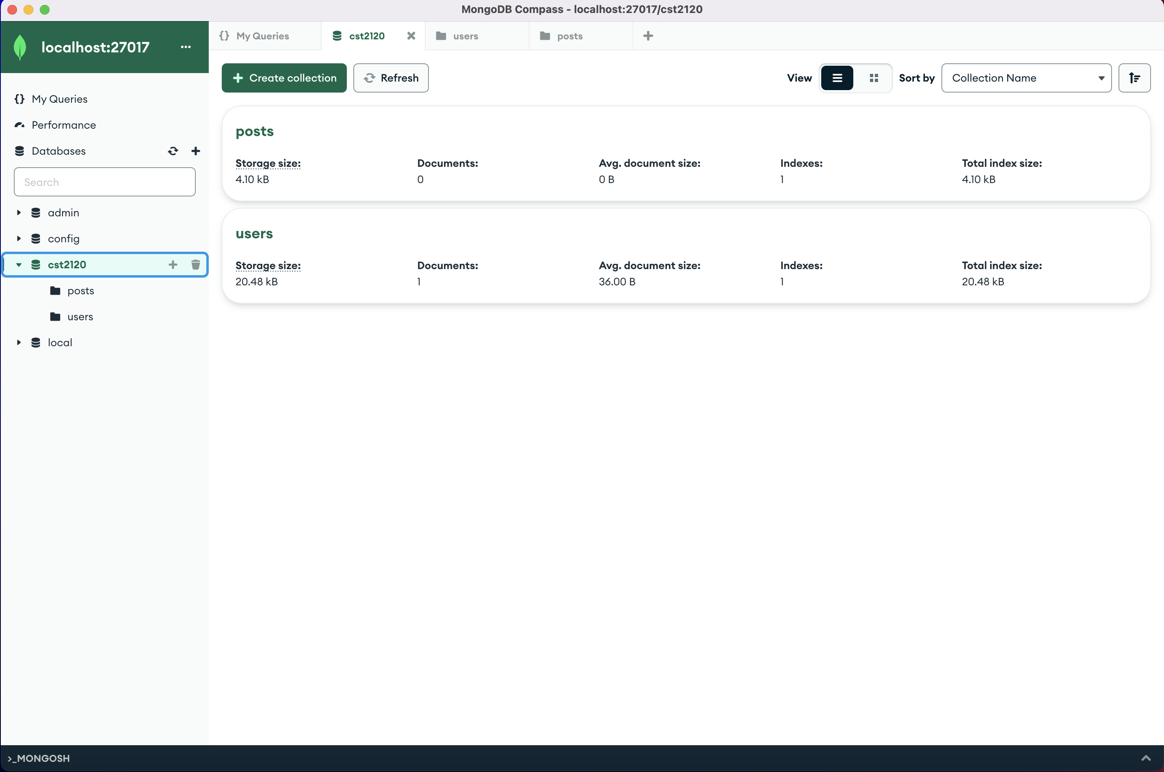

Here is the post collection of the database which comprise of the relevant data regarding post for the social media platform. For example, when creating and interacting with the video/ image.

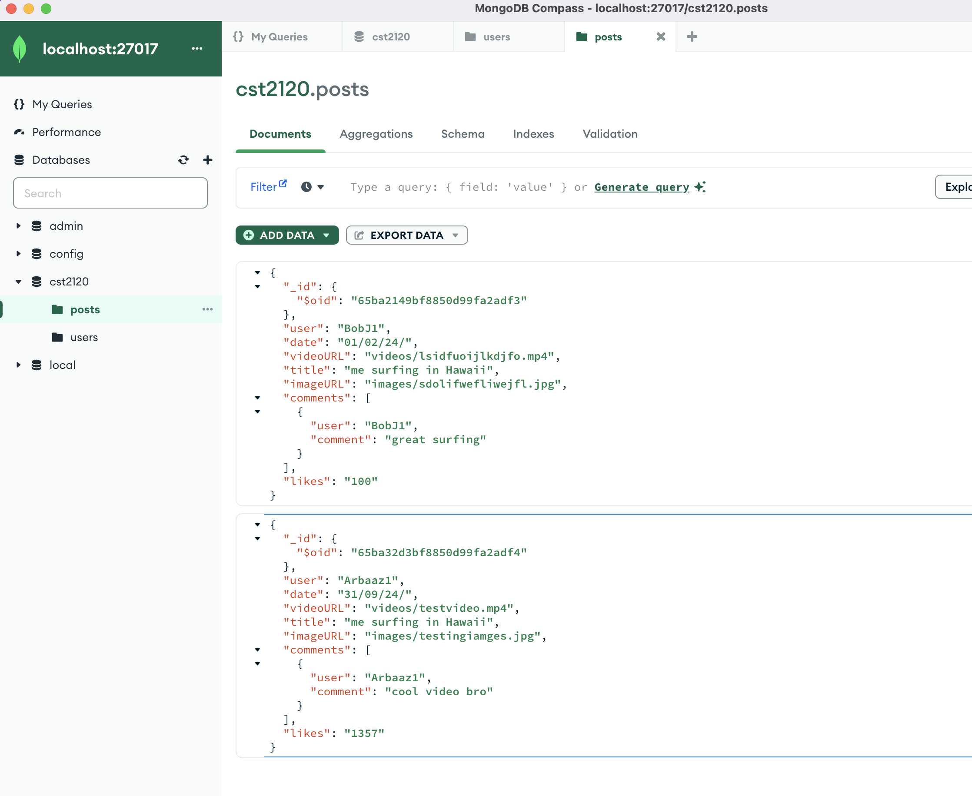

## Screenshots 2 of the MongoDB

Here is the user’s collection of the database which comprise of the relevant data regarding Users for the social media platform. For example, when creating new users and providing the user customisation for there our profile.

